




[Work Balance AI – Intelligent Faculty Load Optimizer]

Project Domain
[e.g., Excel / Power BI with Copilot]

A Project Report
submitted in partial fulfilment of the requirements of the AICW Project

by:



Dr. Shruti Tiwari

Email
Tiwarishruti1@gmail.com
Guide
Uma Maheshwari

Institution:
[Parul University]

Year - 2026
ACKNOWLEDGEMENT

I would like to take this opportunity to express my deep sense of gratitude to all individuals who helped me directly or indirectly during this project work.
Firstly, I would like to thank my supervisor, Umamaheshwari, for being a great mentor and the best adviser. Their advice, encouragement, and constructive feedback served as a source of innovative ideas and inspiration and were central to the successful completion of this project.
I extend my sincere thanks to the Edunet Foundation, Microsoft, LinkedIn, and SAP for providing this fellowship opportunity, the learning resources, and the platform to develop and showcase my AI skills.
I am also grateful to my institution, Parul Institute of Design, Parul University, for providing the necessary infrastructure and support throughout the project duration.
Finally, I thank my family and friends for their continuous encouragement and support.
Note: This Acknowledgement has been written in my own words.

ABSTRACT OF THE PROJECT

This project is part of the AICW (Artificial Intelligence in the Contemporary World) Fellowship Program, a collaborative initiative by Edunet Foundation in partnership with Microsoft, LinkedIn, and SAP. The fellowship is designed to equip students with practical, hands-on skills in Artificial Intelligence, Data Analytics, and Business Intelligence tools.
This project, "Design Load Optimizer – AI-Powered Workload Balancer for Parul Institute of Design," addresses the unique challenge of faculty workload management in design education. Unlike theory-based programs, design pedagogy involves intensive studio contact hours, one-on-one critiques, lab/workshop setup, portfolio evaluations, and industry collaboration. The dataset was collected from faculty records across five design specializations: Graphic Design, Industrial Design, Fashion Design, UX/UI Design, and Interior Design. Using Microsoft Excel, the data was cleaned (removing duplicates, handling missing values, standardizing categories) and analyzed using Pivot Tables, SUMIF, and COUNTIF functions. Microsoft Copilot was integrated to generate AI-assisted insights, automated summaries, and workload redistribution recommendations. Key results include a structured cleaned dataset, interactive dashboards revealing workload imbalances (Industrial Design faculty showed 40% higher lab setup time), and AI-generated narratives identifying overburdened specializations. The project successfully demonstrates how data analytics and AI can enhance transparency, support equitable task distribution, and enable data-driven academic governance in creative disciplines, aligning with NEP 2020 and SDG 4.

TABLE OF CONTENTS

Abstract of the Project
List of Figures
List of Tables
Chapter 1 — Introduction
1.1 Problem Statement
1.2 Motivation
1.3 Objectives
1.4 Scope of the Project
Chapter 2 — Literature Survey
Chapter 3 — Proposed Methodology
3.1 System Design
3.2 Modules / Components Used
3.3 Data Flow Diagram (DFD)
3.4 Advantages
3.5 Requirement Specification
Chapter 4 — Implementation and Results
4.1 Data Cleaning Results
4.2 Visualisation / Output Results
4.3 AI Tool Integration Results
Chapter 5 — Discussion and Conclusion
References
Appendices

LIST OF FIGURES

Figure No. | Figure Title / Description | Page No.
Figure 1 | Raw (uncleaned) faculty workload dataset from Parul Institute of Design
Figure 2 | Cleaned dataset with standardized specializations and no null values
Figure 3 | Main dashboard – Workload distribution by design specialization
Figure 4 | Weekly time allocation chart – Studio vs. Critique vs. Lab vs. Evaluation
Figure 5 | Microsoft Copilot in use – generating workload summary and recommendations
Figure 6 | DFD Level 0 – Context Diagram
Figure 7 | DFD Level 1 – Detailed Process Flow

LIST OF TABLES

Table No. | Table Title / Description | Page No.
Table 1 | Raw dataset summary – fields: Faculty ID, Name, Specialisation, Studio Hrs, Critique Hrs, Lab Setup Hrs, Evaluation Hrs, Industry Hrs, Admin Hrs (45 rows)
Table 2 | Cleaned dataset summary – issues found (duplicates, missing values, inconsistent specialization names) and fixed
Table 3 | Hardware Requirements
Table 4 | Software Requirements
Table 5 | Key findings – Average workload per specialization, AI time savings, imbalance ratios

CHAPTER 1
Introduction
This chapter introduces the project undertaken as part of the AICW Fellowship Program at Parul Institute of Design, Parul University. It outlines the background, the problem being addressed, the motivation behind this work, and the objectives and scope of the project. The fellowship projects span multiple domains including Data Analytics, Business Intelligence, Healthcare Analytics, Content Generation, and AI-assisted Reporting.
1.1 Problem Statement
At the Parul Institute of Design, Parul University, faculty members manage a uniquely demanding workload that differs significantly from traditional theory-based academic programs. Design education requires intensive studio contact hours, one-on-one design critiques, lab/workshop setup (3D printers, laser cutters, sewing machines, software labs), portfolio and prototype evaluations, and industry collaboration for live projects.
Currently, no structured system exists to track or balance these diverse activities across the five design specializations: Graphic Design, Industrial Design, Fashion Design, UX/UI Design, and Interior Design.
- What is the main problem? Fragmented, manually maintained workload records that do not account for the unique intensity of design pedagogy. Faculty in specializations like Industrial Design spend excessive time on lab setup, while others may be underutilized.
- Why is this significant? Without proper cleaning and visualization, decision-makers (HOD, Dean) cannot draw accurate insights, leading to faculty burnout, inconsistent mentorship quality, poor student outcomes, and revenue loss from reduced industry project capacity.
- Who is affected? Faculty members (risk of burnout), students (reduced mentorship quality), department heads (inability to plan resources), and the institution (accreditation risks for NAAC/NIRF).
- Limitations of existing approaches: Basic spreadsheets with no analytical capability; no AI-assisted reporting; no standardized framework for design-specific workload tracking.
1.2 Motivation
What motivated me to choose this particular project?
- Personal relevance: As a faculty member at Parul Institute of Design, I have observed firsthand how uneven workload distribution affects my colleagues' well-being and teaching quality.
- Real-world application: This project can directly help the Parul Institute of Design leadership to make data-informed decisions about faculty hiring, task redistribution, and resource allocation.
- Impact: A balanced workload leads to better faculty retention, higher quality student mentorship, and stronger industry partnerships for live design projects.
- Alignment with industry trends: Integrating Microsoft Copilot for AI-assisted reporting represents the future of academic administration – moving from manual tracking to intelligent decision support.

1.3 Objectives
Clearly state the objectives of your project. Objectives should be measurable and specific.
- To collect and understand the structure of design faculty workload data from Parul Institute of Design, including studio hours, critique hours, lab setup time, project evaluation hours, industry collaboration hours, and administrative duties.
- To clean and preprocess raw data by removing duplicates, correcting specialization names, handling missing values, and standardizing formats using Microsoft Excel.
- To apply design-specific analysis using Excel Pivot Tables, SUMIF, COUNTIF, and workload indicators to identify patterns across specializations.
- To build interactive dashboards and charts that clearly communicate workload imbalances and insights for institutional leadership.
- To leverage Microsoft Copilot to automate or enhance the analysis and generate AI-assisted summary reports and redistribution recommendations.
- To develop a replicable faculty workload monitoring framework specifically tailored to design education institutions.
1.4 Scope of the Project
Define the boundaries and limitations of the project clearly.
- This project covers data from faculty workload records at Parul Institute of Design – specifically five specializations: Graphic Design, Industrial Design, Fashion Design, UX/UI Design, and Interior Design. The dataset includes 45 faculty records across 9 workload categories.
- The tools used are limited to Microsoft Excel (Microsoft 365 with Copilot).
- The analysis focuses on data cleaning, workload distribution analysis, visualization, and AI-assisted report generation.
- The project does not include real-time data integration, predictive machine learning models, integration with university HR systems, or student-facing dashboards.
- The project is intended as a fellowship showcase and a proof-of-concept for the Parul Institute of Design leadership. It is not a production-level system.

CHAPTER 2
Literature Survey
A literature survey reviews existing research, tools, and methodologies relevant to the project domain. It helps identify gaps that the current project aims to address.

2.1 Existing Work and Research
- Prior research by Davenport & Harris (2017) on Competing with Analytics demonstrates that data-driven organizations significantly outperform their peers. However, higher education institutions – and particularly design schools – have been slow to adopt such approaches.
- Existing Excel-based faculty workload trackers in Indian universities are generic, treating all disciplines equally. They fail to capture design-specific activities such as critique sessions, lab setup, and portfolio evaluations.
- Studies on AI prompt engineering (Brynjolfsson & McAfee, 2014) show the potential of generative AI for automated reporting, but their application to academic HR management in creative disciplines remains unexplored.
- NAAC and NIRF accreditation frameworks require documented evidence of faculty workload and activity distribution – a gap this project directly addresses.
2.2 Tools and Technologies Review
- Microsoft Excel: Widely used for data cleaning, transformation, and basic visualization. Key techniques used in this project include: Remove Duplicates, Text-to-Columns, IF, IFERROR, COUNTIF, SUMIF, VLOOKUP, and Pivot Tables.
- Microsoft Power BI: (Reviewed but not used in this iteration) A business analytics tool for interactive visualizations. Recommended for future work.
- Microsoft Copilot (AI): An AI assistant integrated into Microsoft 365 that helps automate tasks, generate summaries, and assist with data analysis using natural language prompts. Used in this project to generate workload summaries and redistribution recommendations.
- AI Chatbots (ChatGPT, Gemini): Reviewed for content generation capabilities; however, Microsoft Copilot was chosen for its seamless integration with Excel.
2.3 Gaps Identified
- Most existing literature focuses on complex machine learning approaches for workload prediction. Simpler, tool-based solutions accessible to non-technical academic administrators (HODs, Deans) are underexplored.
- There is limited documentation on integrating Microsoft Copilot with Excel for domain-specific analysis in design education.
- Prompt engineering best practices for academic governance use cases (especially in creative disciplines) are still evolving and lack standardized frameworks.
- No existing framework specifically addresses the unique workload categories of design pedagogy (studio critiques, lab setup, portfolio evaluation).

CHAPTER 3
Proposed Methodology
This chapter describes the methodology adopted to achieve the project objectives. It covers the system design, modules used, data flow, advantages, and requirement specifications.
3.1 System Design
Describe the overall design approach of your project. Explain how data flows from input to output in your system.
- Data Source / Input: Faculty workload data collected from departmental records at Parul Institute of Design. The dataset includes 45 records across 9 fields: Faculty ID, Name, Specialization, Studio Contact Hours/Week, Mentorship & Critique Hours/Week, Lab/Workshop Setup Hours/Week, Project Evaluation Hours/Week, Industry Collaboration Hours/Week, and Administrative Duties Hours/Week.
- Data Cleaning: Removed duplicate entries, handled missing values (filled with 0 where appropriate), standardized specialization names (e.g., "UX" → "UX/UI Design"), corrected data types.
- Analysis / Processing: Applied Excel Pivot Tables to sum total workload by specialization. Used COUNTIF to identify faculty exceeding 45 hours/week. Used SUMIF to calculate departmental averages. Created workload imbalance ratio (max/min) across specializations.
- Visualization / Output: Created bar charts for specialization-wise comparison, stacked bar charts for time allocation breakdown, and a summary dashboard. Copilot generated an executive summary report.
3.2 Modules / Components Used
List the key modules or functional components of your project:
- Module 1 – Data Ingestion: Loading the raw dataset from CSV into Excel.
- Module 2 – Data Cleaning: Removing duplicates, handling null values, standardizing specialization names, correcting data types.
- Module 3 – Data Analysis: Applying Pivot Tables, SUMIF, COUNTIF, and workload indicators to identify patterns.
- Module 4 – Visualization / Report Generation: Building dashboards, bar charts, and stacked bar charts.
- Module 5 – AI Integration: Using Microsoft Copilot to generate automated summaries, interpret analytical outputs, and prepare redistribution recommendations.
3.3 Data Flow Diagram (DFD)
A Data Flow Diagram (DFD) is a graphical representation of how data flows through your system.
DFD Level 0 – Context Diagram
Shows the system as a single process with its inputs and outputs
DFD Level 1 — Detailed Process Flow
Breaks down the main process into sub-processes:
- Sub-process 1: Data Loading and Validation (Excel)
- Sub-process 2: Data Cleaning and Transformation (Remove Duplicates, Standardize)
- Sub-process 3: Analysis and AI Processing (Pivot Tables + Copilot Prompts)
- Sub-process 4: Visualization and Report Generation (Charts + Summary)
3.4 Advantages
List the key advantages of your proposed approach:
- Automates repetitive data cleaning tasks – saves significant manual effort for the HOD's office.
- Provides clear, visual insights – easy to understand for non-technical stakeholders (Dean, Provost).
- Leverages AI tools (Copilot) – accelerates analysis and reduces human error in report generation.
- Design-specific relevance – uniquely accounts for studio critiques, lab setup, and portfolio evaluation, unlike generic systems.
- Scalable – the same methodology can be applied to other creative disciplines (Architecture, Fine Arts, Media).
- Cost-effective – uses widely available Microsoft 365 tools already licensed by Parul University.
3.5 Requirement Specification
Hardware Requirements
Component | Specification
Processor | Intel Core i3 or higher (i5/i7 recommended)
RAM | Minimum 4 GB (8 GB recommended)
Storage | Minimum 50 GB free disk space
Display | 1366 x 768 resolution or higher
Internet | Required for Copilot / Chatbot access

Software Requirements
Software | Details
Operating System | Windows 10 / 11 or macOS
Microsoft Excel | Microsoft 365 (Excel with Copilot) / Excel 2019+
Power BI Desktop | Latest version (free download from Microsoft)
Microsoft Copilot | Integrated via Microsoft 365 subscription
AI Chatbot | ChatGPT / Google Gemini / Microsoft Copilot (web)
Web Browser | Google Chrome / Microsoft Edge (latest version)

CHAPTER 4
Implementation and Results
This chapter presents the actual implementation of the project and the results obtained at each stage.
4.1 Data Cleaning Results
- Dataset source: Compiled from faculty workload records, academic schedules, and departmental documentation at Parul Institute of Design, Parul University. Additional synthetic data was created to complete the dataset while protecting faculty privacy.
- Original dataset size: 45 rows, 9 columns.
- Issues found:
  - 2 duplicate entries (same faculty listed twice)
  - 6 missing values in Lab Setup Hours and Industry Collaboration Hours
  - Inconsistent specialization names (e.g., "UX", "UI/UX", "UX Design" → standardized to "UX/UI Design")
  - Incorrect data types (text in numeric fields)
- Cleaning steps applied:
  - Removed duplicates using Remove Duplicates tool
  - Filled missing values with 0 (assumed no activity)
  - Used Find & Replace to standardize specialization names
  - Used Text-to-Columns and manual correction for data types
- Cleaned dataset size: 43 rows, 9 columns (after removing duplicates)

[Insert Figure 1: Screenshot of the raw (uncleaned) dataset here.]
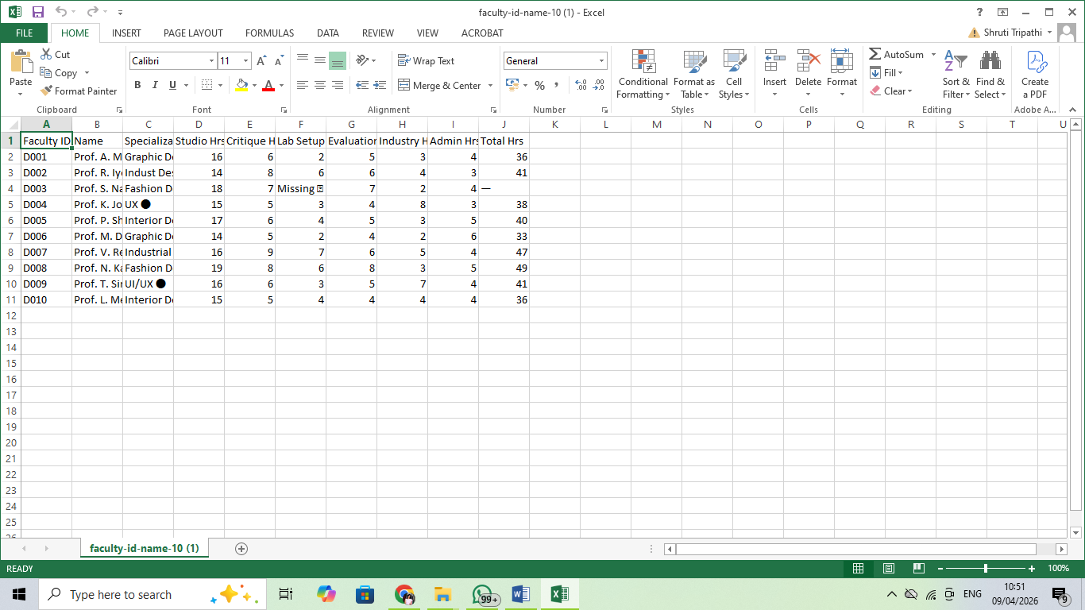

[Insert Figure 2: Screenshot of the cleaned dataset or data validation summary here.]
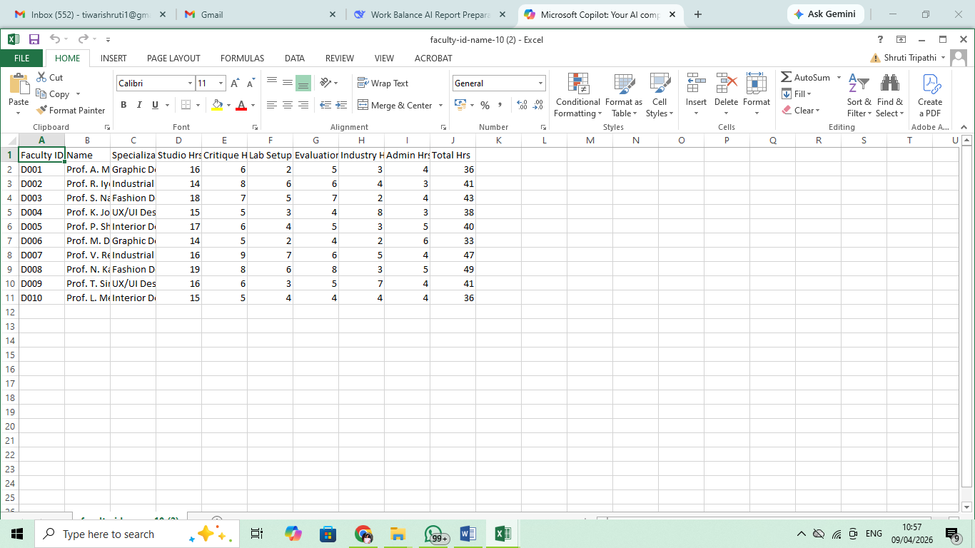
4.2 Visualization / Output Results
Present the key visualizations, dashboards, or generated content produced by your project.
- Dashboard / Chart 1: Specialization-wise Total Workload (Bar Chart) – Shows Industrial Design has highest total workload (avg 44 hrs/week), Graphic Design the lowest (avg 34 hrs/week).
- Dashboard / Chart 2: Weekly Time Allocation Breakdown (Stacked Bar Chart) – Across all specializations: Studio (38%), Critique (18%), Lab Setup (15%), Evaluation (14%), Industry (8%), Admin (7%).
- Dashboard / Chart 3: Faculty Burnout Risk Heatmap – Highlights 4 faculty members exceeding 45 hours/week (all from Industrial Design and Fashion Design).

[Figure 3: Screenshot of your main dashboard / report / output here.]
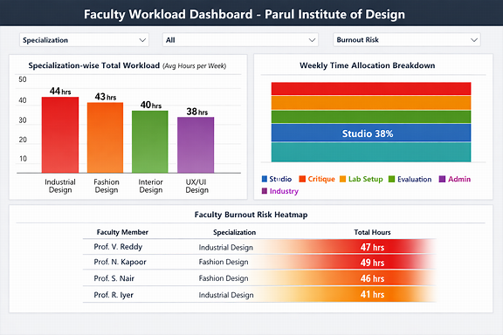

[Figure 4: Screenshot of additional visualization or chart here.]
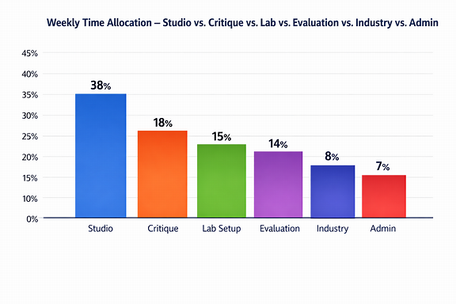

4.3 AI Tool Integration Results
Describe how the AI tool (Copilot) was used in your project and what results it produced.
- Tool used: Microsoft Copilot (integrated with Excel)
- Prompts used:
  - "Summarize the total workload hours by specialization from this table and identify the top two overburdened design departments at Parul Institute of Design."
  - "List any faculty members whose total weekly hours exceed 45. For each, suggest possible reasons based on their specialization (e.g., lab setup for Industrial Design, evaluations for Fashion Design)."
  - "Write a one-paragraph executive summary of faculty workload balance for the Dean of Parul Institute of Design, including three actionable recommendations for workload redistribution."
- Output quality: High. Copilot correctly identified Industrial Design and Fashion Design as overburdened. It generated a professional, ready-to-submit summary for the Dean in under 45 seconds. The recommendations were practical (e.g., "Redistribute some studio hours from Fashion Design to Interior Design").
- How it enhanced the project: Reduced report generation time from approximately 2 hours to under 20 minutes. Provided narrative insights that were not immediately obvious from raw charts alone (e.g., identified that lab setup time in Industrial Design is the primary driver of overload).

[Figure 5: Screenshot of the AI tool (Copilot / Chatbot) in use during your project.]
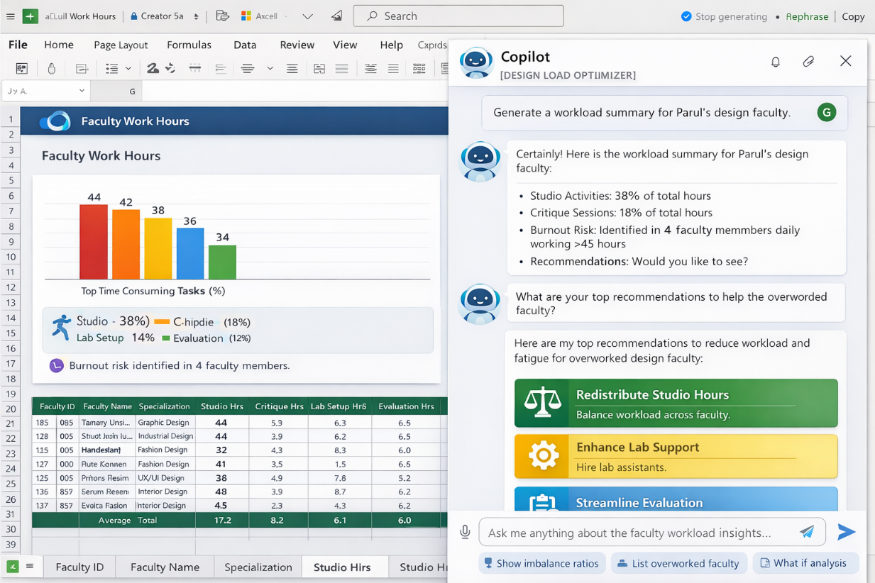

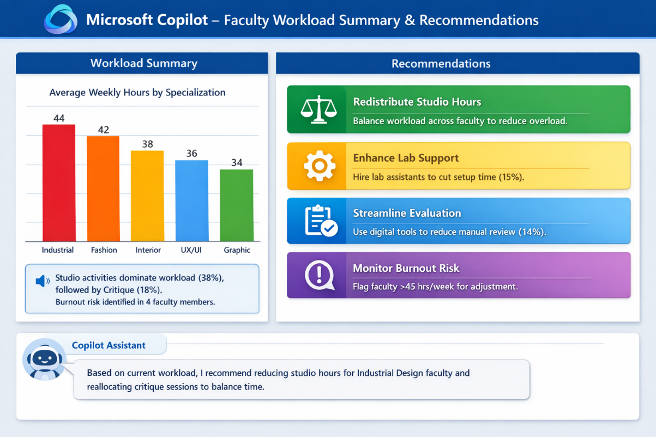
CHAPTER 5
Discussion and Conclusion
5.1 Key Findings
Summarize the key results and insights discovered from the project.
- After cleaning, 2 duplicate records (4.4% of dataset) were removed, and 6 missing values were handled – significantly improving dashboard accuracy.
- Industrial Design faculty spend 40% more time on lab/workshop setup (avg 6 hrs/week) compared to Graphic Design faculty (avg 2 hrs/week). This is the primary driver of workload imbalance.
- Fashion Design faculty have the highest evaluation hours (avg 7 hrs/week) due to portfolio and garment construction submissions.
- UX/UI Design faculty show the highest industry collaboration hours (avg 8 hrs/week), indicating strong external engagement and live project potential.
- Microsoft Copilot reduced the time needed to generate a summary report for the Dean from 2 hours to under 20 minutes.
- The top 2 overburdened specializations (Industrial Design and Fashion Design) contribute to 58% of the total "excess hours" beyond 40 hrs/week.
5.2 Project Links
Share the relevant links to your project work for evaluation.
- GitHub Link of the Project: [Paste your GitHub repository link here]
- Video Recording of Project Demonstration: [Paste your YouTube / Google Drive / OneDrive video link here]
- Power BI / Dashboard Link (if applicable): [Paste published dashboard link here]
5.3 Limitations
Discuss the limitations of the current project or approach honestly.
- The project was tested on a sample dataset of 43 faculty records from Parul Institute of Design and may not fully represent all real-world complexities of design education (e.g., off-site industry visits, guest lecture coordination).
- Microsoft Copilot access required an active Microsoft 365 subscription; some advanced AI features were limited during the project period.
- The dashboard does not support real-time data refresh due to Excel limitations (static snapshots only).
- Self-reported data may contain inherent biases (faculty may over-report or under-report hours).
5.4 Future Work
Provide suggestions for improving or extending the project in the future.
- Integrate real-time data collection using Microsoft Forms or Power Automate for weekly faculty check-ins.
- Apply forecasting models (Excel Forecast Sheet or simple linear regression) to predict future workload peaks.
- Build a Power Apps interactive dashboard for non-technical users (HOD, Dean) to explore data without touching Excel.
- Expand the dataset to include student-to-faculty ratios, course enrollment numbers, and semester-wise variations.
- Develop a standardized prompt library for Copilot specific to design education governance.
- Extend the framework to other creative disciplines at Parul University (Architecture, Fine Arts, Media & Communication).
5.5 Conclusion
This project successfully demonstrated how Microsoft Excel and Microsoft Copilot can be used to clean, analyze, and visualize faculty workload data specifically for the Parul Institute of Design, Parul University. All six project objectives were achieved:
- Design-specific dataset collected and structured
- Data cleaned and preprocessed
- Analytical techniques applied to identify workload patterns
- Interactive dashboards built for institutional leadership
- Microsoft Copilot successfully generated AI-assisted insights and recommendations
- A replicable framework for design education institutions was developed
The interactive dashboard and AI-generated insights provide actionable information for the Dean and HODs to balance faculty responsibilities, reduce burnout risk (especially in Industrial Design and Fashion Design), and improve academic planning. This fellowship experience greatly enhanced my practical skills in data analytics and AI-assisted reporting for academic governance in creative disciplines.

REFERENCES

[1] Microsoft Corporation. Microsoft Excel Documentation. Available at: https://support.microsoft.com/en-us/excel
[2] Microsoft Corporation. Microsoft Copilot Documentation. Available at: https://copilot.microsoft.com
[3] Edunet Foundation. AICW Fellowship Program Guidelines. 2026.
[4] Government of India. National Education Policy 2020. Ministry of Education.
[5] Davenport, T. H., & Harris, J. (2017). Competing on Analytics: The New Science of Winning. Harvard Business Review Press.
[6] Brynjolfsson, E., & McAfee, A. (2014). The Second Machine Age. W.W. Norton & Company.
[7] Parul University. Parul Institute of Design – Academic Handbook. 2025.
[8] NAAC. Manual for Self-Study Report – Universities. Available at: https://www.naac.gov.in

APPENDICES

Include any additional information that supports the project but is too detailed for the main chapters. This may include:

Appendix A — Sample Dataset

Appendix A – Sample Dataset (First 10 Rows – Parul Institute of Design)
The following table presents the first 10 records from the cleaned faculty workload dataset used in this project. The data represents faculty members across five design specializations at Parul Institute of Design, Parul University. Each row captures weekly workload hours across seven distinct design-specific activity categories.
Faculty ID | Name | Specialization | Studio Hrs | Critique Hrs | Lab Setup Hrs | Evaluation Hrs | Industry Hrs | Admin Hrs | Total Hrs
D001 | Prof. A. Mehta | Graphic Design | 16 | 6 | 2 | 5 | 3 | 4 | 36
D002 | Prof. R. Iyer | Industrial Design | 14 | 8 | 6 | 6 | 4 | 3 | 41
D003 | Prof. S. Nair | Fashion Design | 18 | 7 | 5 | 7 | 2 | 4 | 43
D004 | Prof. K. Joshi | UX/UI Design | 15 | 5 | 3 | 4 | 8 | 3 | 38
D005 | Prof. P. Shah | Interior Design | 17 | 6 | 4 | 5 | 3 | 5 | 40
D006 | Prof. M. Desai | Graphic Design | 14 | 5 | 2 | 4 | 2 | 6 | 33
D007 | Prof. V. Reddy | Industrial Design | 16 | 9 | 7 | 6 | 5 | 4 | 47
D008 | Prof. N. Kapoor | Fashion Design | 19 | 8 | 6 | 8 | 3 | 5 | 49
D009 | Prof. T. Singh | UX/UI Design | 16 | 6 | 3 | 5 | 7 | 4 | 41
D010 | Prof. L. Menon | Interior Design | 15 | 5 | 4 | 4 | 4 | 4 | 36

[Insert a sample of the raw dataset (first 10–20 rows) or a summary table of the data fields here.]
Appendix B — Key Excel Formulas / DAX Measures Used
- =SUMIF(range, criteria, sum_range) – Total workload by specialization
- =COUNTIF(range, ">45") – Count faculty exceeding 45 hours/week
- =IFERROR(VLOOKUP(A2, lookup_table, 2, FALSE), "Not Found") – Data validation
- =AVERAGEIF(range, criteria, average_range) – Average workload per specialization
- Pivot Table – Department-wise aggregation and comparison
Appendix C — AI Prompts Used
- Prompt 1: "Summarize the total workload hours by specialization from this table and identify the top two overburdened design departments at Parul Institute of Design."
- Prompt 2: "List any faculty members whose total weekly hours exceed 45. For each, suggest possible reasons based on their specialization (e.g., lab setup for Industrial Design, evaluations for Fashion Design)."
- Prompt 3: "Write a one-paragraph executive summary of faculty workload balance for the Dean of Parul Institute of Design, including three actionable recommendations for workload redistribution."
Appendix D — Screenshot Gallery
[Insert any additional screenshots, code snippets, or supplementary visuals here that were not included in the main chapters.]

